FREE COVID-19 DRIVE THRU TESTING
CLINIC in Jindabyne
Call 1800 999 880 (option 2) to register OR
use our testing form at snswlhd.health.nsw.gov.au
Open Daily
9am – 5pm
Jindabyne HealthOne
5 Thredbo Terrace, Thredbo
HELP STOP THE SPREAD
To protect lives & stay safe
Isolate if you are unwell
Arrange to get tested
Maintain physical / social distancing
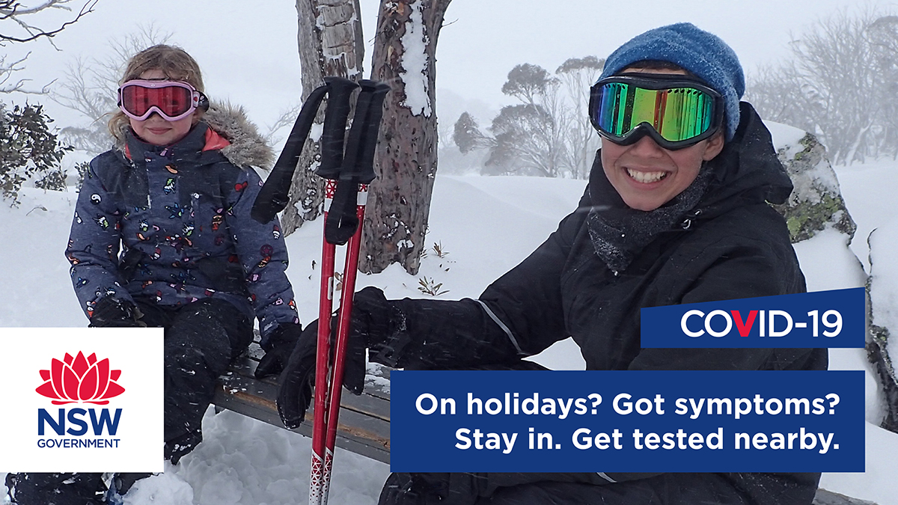 download the COVIDSafe app

