FREE COVID-19 TESTING CLINIC
In Thredbo
Call 1800 999 880 (option 2) to register OR use our enquiry form at snswlhd.health.nsw.gov.au
Tuesday and Thursday
9.30am – 12.30pm

Captain Coachman Room
(behind information centre)
Friday Drive, Thredbo
HELP STOP THE SPREAD
To protect lives & stay safe
Stay in if you are unwell
Arrange to get tested
Maintain physical / social distancing
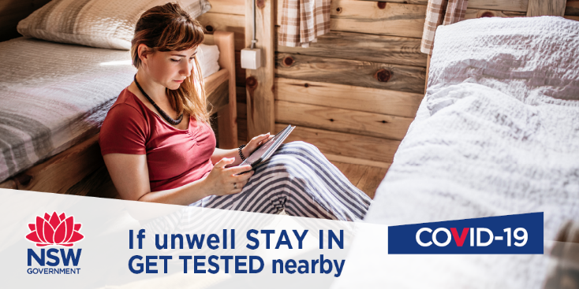
download the COVIDSafe app

